Self Guided Project

This was a self guided project in which I had the opportunity to do anything on my own whether that be recording or using midi software. I decided to make a movie soundtrack because it is something I've always been interested in doing. For years I made hip-hop beats so I was accustomed to using midi instruments and had a variety of sounds to choose from. I wanted to make a suspenseful, thrilling, or mysterious type of sound track. I used fl studio to create this project because it's very midi friendly when it comes to making creations. The main vst instrument that I used for this project was Nexus. It comes equipped with virtually any sound you could imagine. I used dark strings, a cello, two pianos, various pad sounds, and a harp.

Creative Process/Writing
I went with nexus, a very common virtual instrument for anyone that produces music such as edm, hip-hop, etc. Nexus is loaded with tons of presets that allow any user to pick and choose a sound of their liking. I started out with a basic grand piano and later switched to another piano I liked.

Once I had my starting melody, that's when I began to get really creative. I added multiple patterns inside the pattern maker of fl studio. I decided to go with dark string to really add some bottom end and feel into it. This would add suspense or worry for the audience.
I then added other instruments such as a lighter piano, harp, cello, and a mysterious sounding pad that would later go along with my intro section.
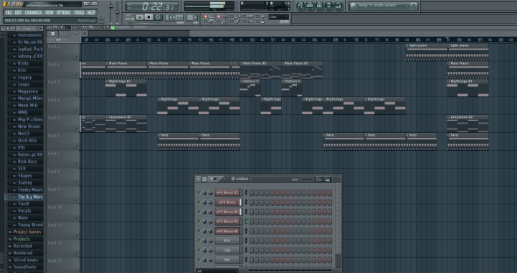

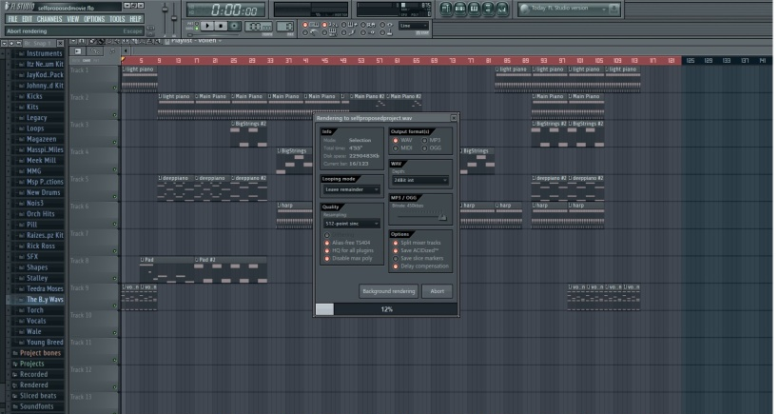
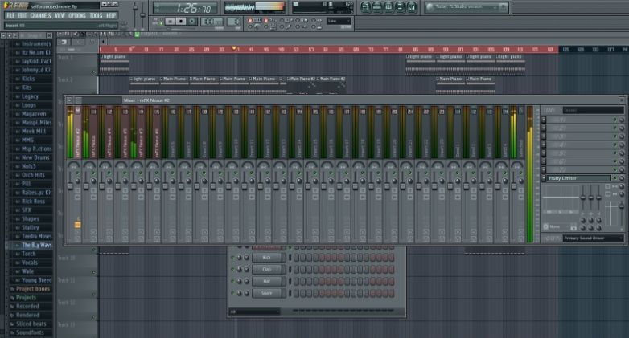
After I had created all of my patterns and laid them out into a designed order, I assigned each separate track to a channel in the mixer. I did this so that I could export each stem so that they were able to be mixed in Studio One, my preferred DAW for mixing. I also had a select few of plug-ins that I run from Studio One which I cannot use in Fl Studio.

Post Production

In this step I loaded all of the previous tracks into studio one and mixed them accordingly. I used the pro eq on most tracks to cut out anything that would interfere with my "Big Strings" track. I wanted them to have a lot of bass, so I engineered each instrument in its own eq range. I also added an instrument verb send and sent both of my piano tracks to the MPXI native reverb plug-in. This would give a larger and more distant feel to the piano.

Once I had all of my individual tracks sitting in the mix where I wanted them, I then went to my mix bus and added a multiband compressor free from Reapers selection of plug-ins. This would ensure that all of my frequency levels were in check and nothing was too overpowering. I then went and added an overall eq to the mix added some low end as well as some high end. To finish off the mix and make sure that my levels were as loud as possible without any feeling of compression, I used the Limiter6 plug-in. This plug-in allows me to see what's happening with my mix in real time with their level meters.

My very last step in this process was to automate the master levels for the parts that were more intense or had a buildup. I went through the track and automated each section that I wanted to be louder or have a volume increase built up to. This allowed me to keep instrument levels the same while changing the overall volume of the soundtrack itself. I also went back into the mix bus and inserted a binaural pan plug-in. This plug-in takes existing sounds that are panned and spreads them even further creating a larger stereo image.

Conclusion
I'm very pleased with the outcome of my project. I think it came out great and sounds professional. The only thing that I would change about this project is to have a co-writer help with some of the melodies or background harmonies. I think that would have made it even more suspenseful and the listener would be more drawn in if it were to be played as a movie soundtrack. I also would have like to experiment with surround sound but those resources aren't available to me yet. Overall, this was another great learning experience and I am please with my project.

