Single Instrument Project

This is a solo instrument project in which I used one instrument to record in the entire process. During this project I planned to record a heavy metal track using one guitar and later. For the drums I added a virtual drum kit to complete the song. I decided to create an original intro, chorus, and verse instead of recording a cover to just have little bit more fun with it.

Setup
Since I didn't have the necessary amp/cab to come out with an authentic metal tone, I decided to use a virtual amp plug-in. The best one I knew of that I could get my hands on was "Ampire" created by Presonus. I used my Schecter guitar with humbucker pickups plugged straight into my 1818vsl and gain staged from there into Presonus' Studio One.

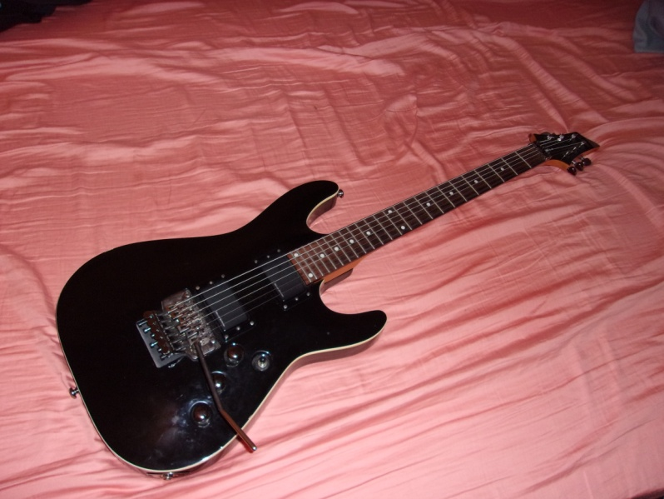

Post Production

The first thing I started with in this phase was getting the right guitar tone. After perfecting my tone in Ampire, I added a multiband compressor to all guitar tracks so that the palm muting of the guitar wouldn't become out of control. All guitar tracks were cleaned up and trimmed. Some parts that seamed slightly off time were fix using elastic audio on the elastic pro setting.

I recorded two of the exact guitar parts for each section of the song and panned them hard left and hard right to create a dramatic stereo image for the guitars. This is because I really want the listener to feel the guitars and hear the tone and I think that's really the feel of heavy metal. I then over dubbed some higher guitar harmonies on the chorus, again panning hard left and right. All Guitar tracks were sent into a bus where I only added an eq to remove some unwanted frequencies.

Next I moved onto my bass tracks. I had recorded the same melodies and riffs only using single notes. I then used a little trick and transposed by guitar down by 12 semitones making it sound just like a bass. I duplicated each part on its own track creating two identical bass tracks. The first track is my main bass track where I added a compressor and took out all upper frequencies while adding an Ampire preamp rack to dial in as much bass tone as I need. My duplicated track was my "grit" track where I took all upper frequencies and added a distortion.

Both bass tracks were sent to a bass bus where I added a multiband compressor to even out all the tones of the bass mix so that it wouldn't be cutting into the guitars or kick of the drum.

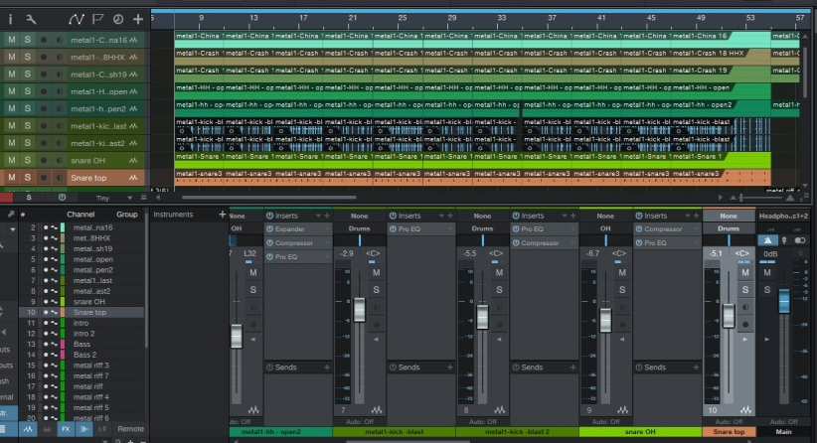
I next mixed all of my virtual drum parts individually after imported the stems from a free program called "Hydrogen". There wasn't much need to add compression anywhere due to the fact they were all virtual instruments. I did however add some slight eq to the snare and kick and took off any lower frequencies of the cymbals. Cymbals went into an overhead bus while all other drums went into a drum bus. Both buses were sent to a drum room where I added a reverb plug-in to simulate my room sound.
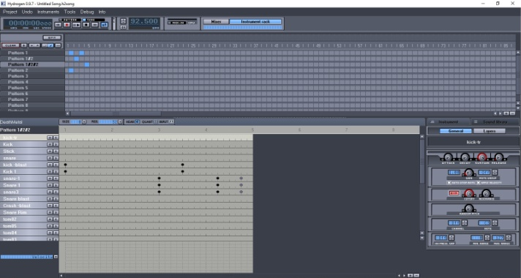

Hydrogen

I used another multiband compressor to keep frequencies balanced while still have the kick and snare punch out in the mix.

In the drum room, I used the setting "NICE STUDIO" because I felt that it gave a really realistic drum room sound.

Throughout the song I added other things such as automation. Halfway through the song there is a breaking point where all instruments stop and then a single guitar comes in. When all instruments come to a stop, a long delay is added to keep in reverberating until the next instrument comes in.

In the stage of mastering the final mix I added a limiter to prevent clipping and also added a multiband compressor. I compressed only slightly on frequencies that were peaking and brought out some lower frequencies as well as mids.

Reflection

Overall, this project was a success and I couldn't be happier with the results. I reached all of my goals and came out with a final product better than expected. The only thing I would have changed is to use a real amp cab if available instead of a plug-in. What I learned most in this project is that you don't need to overdo things such as compression and equalization. Doing things little by little can result in a really nice outcome and not destroy a mix.

